Part I

Assumption:

未来世界经济将会平稳发展，没有大型的战争或者瘟疫。人们对资源的需求会像过去的几十年一样，有节制的增加。

在开采工艺不变的情况下，油井产量与Hubbert curve大致吻合。

对于石油的产生，学界还存在争议，而我们采用的是生物成油理论：我们认同石油像[煤](https://zh.wikipedia.org/wiki/%E7%85%A4%E7%82%AD" \o "煤炭)和[天然气](https://zh.wikipedia.org/wiki/%E5%A4%A9%E7%84%B6%E6%B0%94" \o "天然气)一样，是古代[有机物](https://zh.wikipedia.org/wiki/%E6%9C%89%E6%9C%BA%E5%8C%96%E5%90%88%E7%89%A9" \o "有机化合物)通过漫长的压缩和加热后逐渐形成的。根据地表有机质的推算，人类已经发现了地球上大部分石油了。这意味着我们将越来越难发现新的油田，尤其是大油田了。

未来的石油科技不会发生革命性的突破。这意味着人类无法再一次用常规方法以外的技术开采有商业价值的油田了。

In the future, the world economy will develop steadily without major wars or plagues. People's demand for resources will increase in a controlled manner as in the past few decades.

In the case of the same production process, the oil well production is roughly in line with Hubbert curve.【引用】

There is still controversy in the academic circles about the production of oil, and we adopt the theory of bio-oil formation: we agree that oil, like coal and natural gas, is gradually formed by ancient organic matter through long compression and heating. According to the calculation of surface organic matter, humans have discovered most of the oil on the earth. This means that it will be more and more difficult for us to find new crystals, especially high power.

This means that mankind can no longer use technologies other than conventional methods to extract commercially valuable alternatives.

Problem analysis:

Although oil is a vital nonrenewable or exhaustible resource, it is buried deep underground, and human beings do not have the ability to completely drain the oil on the earth. Therefore, our definition of oil depletion is the moment when oil loses its value as a commodity. We have to find this moment first.

For oil production, we will be based on the Hubbert Curve theory, which has been proved effective. However, the Hubbert Curve did not consider changes in technology and policies, so we must first adjust the Hubbert Curve model. The adjusted the Hubbert Curve is used to fit the two peak oil peaks that occurred in the last century, and then the third peak oil peak that will appear this century due to the introduction of A technology is isolated for subsequent analysis.

Finally, use the above data to predict the depletion of oil.

石油枯竭的标志：

The signs of oil depletion:

Although oil is a non-renewable resource, it is widely used in all walks of life due to its cheapness. We investigated a large amount of data, and finally based on the data on the ratio of oil consumption by various industries in the world, we set the year when oil production was 2% of oil production in 2019 as a sign of oil depletion. When only 2% of petroleum petroleum can not meet the requirements of transportation functions and heating, and can only be used to produce plastics and special industrial consumables, petroleum at this time must not be used as a commodity to circulate and trade around the world. Therefore, this mark is reasonable.

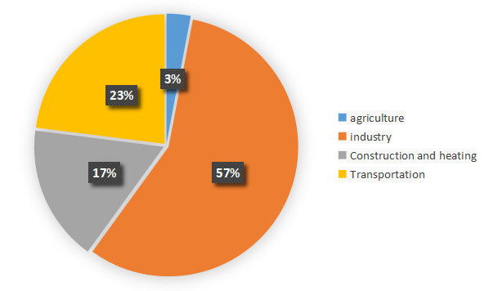

(figure:the ratio of oil consumption by four main industries)

Hubbert model的改进

Improvement of Hubbert model

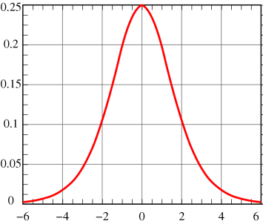The Hubbert curve is an approximation of the production rate of a resource over time.It first appeared in "Nuclear Energy and the Fossil Fuels," geologist [M. King Hubbert](https://en.wikipedia.org/wiki/M._King_Hubbert" \o "M. King Hubbert)'s 1956 presentation to the [American Petroleum Institute](https://en.wikipedia.org/wiki/American_Petroleum_Institute" \o "American Petroleum Institute), as an idealized symmetric curve, during his tenure at the [Shell Oil Company](https://en.wikipedia.org/wiki/Shell_Oil_Company" \o "Shell Oil Company).【0】 It has gained a high degree of popularity in the scientific community for predicting the depletion of various natural resources. The curve is the main component of [Hubbert peak theory](https://en.wikipedia.org/wiki/Hubbert_peak_theory" \o "Hubbert peak theory), which has led to the rise of [peak oil](https://en.wikipedia.org/wiki/Peak_oil" \o "Peak oil) concerns. Basing his calculations on the peak of oil well discovery in 1948, Hubbert used his model in 1956 to create a curve which predicted that oil production in the contiguous United States would peak around 1970.The Hubbert curve of a single oil field is as follows:



(figure: the original Hubbert Curves)

In which P represents the crude oil production per unit time, represents the peak time, are function parameters.

But when we look back on history, we can find that although the world oil production did reach a peak around 1970, the world oil production after 1970 was not as predicted by the curve. There are three main reasons:

Policy changes: Governments of various countries have begun to lift restrictions on oil production and import and export, which has increased the production enthusiasm of oil companies;

Exploring technological innovation: Hydraulic fracturing (fracking) or acidizing may be used to cause a sharp spike in production, and may increase the recoverable reserves of a given well；

Discovery of new oil fields: Hubbert model is only applicable to a single oil field. As the demand for oil increased, explorers became obsessed with discovering new oil fields to generate income.

【0.5】By further reading the literature, we learned that, A secondary recovery project, such as [water](https://en.wikipedia.org/wiki/Water_injection_(oil_production)" \o "Water injection (oil production)) or gas injection for a old oil well or the discovering of a new oil field can bring independent Hubbert Curve. Therefore, with the help of 【1】【2】two documents, we have improved the model: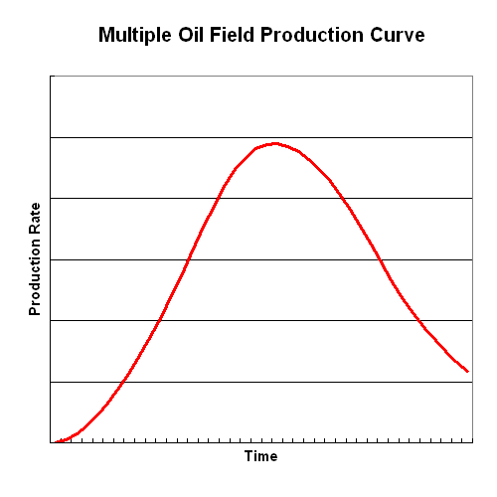



(figure :improved Hubbert Curves)

In which represents the first oil peak in 1970, and represents the second peak of oil after the supergiant Prudhoe Bay field in Alaska was put into production, represents subsequent independent small production peaks due to technological improvements and the discovery of new oil fields.**(In the appendix we provide a detailed generation process.)如此以来，我们便建立了理想Hubbert curve与真实油井产量之间的量化关系。**

**In this way, we have established a quantitative relationship between the ideal Hubbert curve and the real oil well production.**

Using the improved curve, we can better fit the oil production of all known peak times.

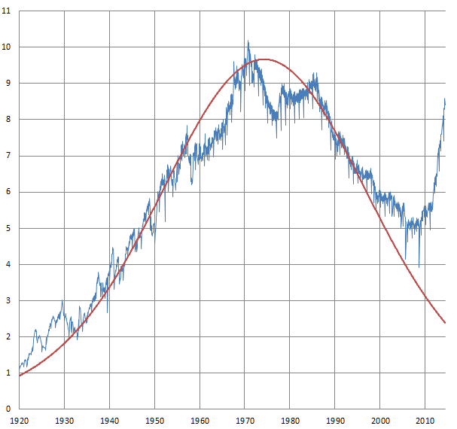

(figure:the fix of the improved curve)

对即将到来的石油峰值进行定量分析

有了第一次石油峰值的Hubbert Curve和本世纪以来原油产量的数据，我们便可以通过分析将新石油峰值的Hubbert Curve独立出来，以方便后续预测。在新的新石油峰值的Hubbert Curve中，每年的原油产率为：

Quantitative analysis of the upcoming peak oil

With the Hubbert Curve of the first peak oil and the data of crude oil production since this century, we can separate the Hubbert Curve of the new peak oil through analysis to facilitate subsequent forecasts. In the Hubbert Curve of the new new peak oil, the annual crude oil production rate is:



In which the represents the observed value of oil production after 1980.

由于我们已经建立了理想Hubbert curve与真实油井产量之间的量化关系，因此接下来要确定新石油峰值Hubbert curve。我们利用逐差法求出2000年与2019年间石油生成效率的变化率，联立方程解出的参数：

Since we have established a quantitative relationship between the ideal Hubbert curve and the real oil well production, the next step is to determine the new peak oil Hubbert curve. We use the progressive difference method to find the rate of change of oil production efficiency between 2000 and 2019, and the parameters solved by the simultaneous equations:



In fact, for the sample of crude oil production rates since this century, for any functions like:



If it satisfies the likelihood ratio of the sample，in which is a given quantity, then the assumption that "A is a regression function of oil production rate" can be accepted. We take "the set containing all functions  satisfying the condition" as set 。Since we have no way of knowing the number and scale of potential, undiscovered oil fields, and the future innovation of crude oil mining technology, for each Hubbert function in , there will be several improved Hubbert Curves that match it. If we take "the set containing all improved Hubbert Curves satisfying the condition" as set Then we can find the most optimistic function and the most pessimistic function for future output from , as shown in the figure:

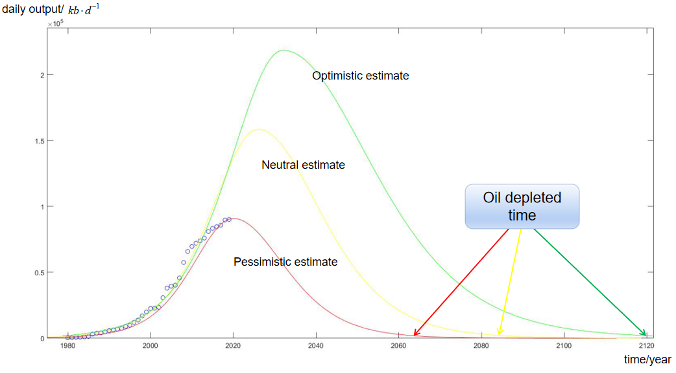

(figure:Different predictions for oil depletion time)

根据我们的计算，石油的枯竭很有可能在2085年左右到来，最早可能在2064年，而最迟将可能在2120年。

According to our calculations, the depletion of oil is likely to come around 2085, the earliest may be 2064, and the latest may be 2120.

灵敏度分析：

我们的模型以Hubbert Curve为基础，着重探讨在市场经济的条件下，油田自然属性科技发展的一般规律给世界石油产率带来的影响。但是，随着世界温室效应和全球变暖的加剧，越来越多的国家和组织开始呼吁，要求减少化石能源的使用。许多国家已经出台了相关政策，限制石油的开采和使用。20世纪70年代，OPEC就以政策的手段限制了石油的开采，导致世界油价大幅上涨。

sensitivity analysis:

Our model is based on the Hubbert Curve and focuses on the impact of the general law of the development of natural attributes of oil fields on the world oil production rate under the conditions of a market economy. However, as the world's greenhouse effect and global warming have intensified, more and more countries and organizations have begun to call for a reduction in the use of fossil energy. Many countries have introduced relevant policies to restrict the exploitation and use of oil. In the 1970s, OPEC used policy measures to restrict oil extraction, leading to a sharp rise in world oil prices.

It is easy to know that The total amount of oil that can be collected ultimately equals to the total amount collected before the oil runs out:



Since the total amount of oil that can be collected ultimately are constant, if we adjust the government’s regulations on oil productivity caps, we can get this picture:

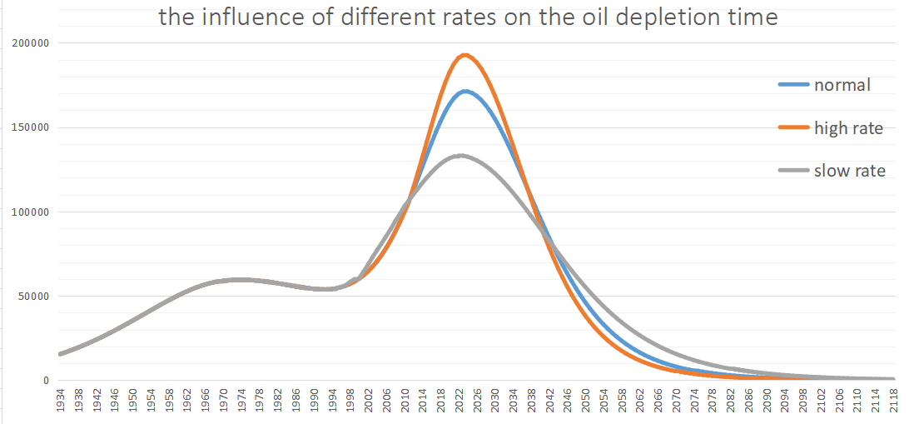

(Figure:the influence of different rates on the oil depletion time)

It can be found that the past policies have effectively affected the next peak of oil extraction rate and delayed the depletion of oil.